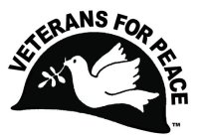Veterans For Peace - Chapter 93

November 2022 Newsletter
… The Utah Phillips – J. David Singer Chapter

Serving Washtenaw, Livingston, Hillsdale, Lenawee, and Jackson Counties.

Local Contact: Bob Krzewinski – 734-487-9058 – wolverbob@gmail.com
www.vfp93.org or on Facebook at www.facebook.com/VFP93

1. Next Veterans For Peace Chapter 93 Meeting - Friday, November 11th, 2pm
The next VFP Chapter 93 meeting will be held at the Chapter's Arlington Michigan display in Ann Arbor's Veterans Park on Friday, November 11th at 2pm. The Arlington Michigan display is at the southwest corner of Veterans Park with parking at the Veterans Memorial Ice Arena parking lot (2150 Jackson Avenue, Ann Arbor, MI 48103 – Google map at https://goo.gl/maps/maKxCCAZ3bzCgQw59). Anyone can participate in this meeting, or any other VFP Chapter 93 event, be they veteran or not. The meeting agenda is as follows…

- Introductions and welcome
- General Business
  - Previous meeting minutes
  - Treasury report
  - Membership
  - VFP 93 Calendar
- 12/10 – International Human Rights Day (celebrates the Universal Declaration of Human Rights) - www.un.org/en/universal-declaration-human-rights
- WW1 Christmas Truce
- J. David Singer (Chapter namesake) birthday (12/7)
  - VFP Outreach
  - Other
- Old & continuing business
  - Truth In Recruiting/Opt-out
  - Michigan Peace Alliance
  - Other
- New Business
  - Camp Grayling expansion
  - Other
- Projects
  - Peace Studies Scholarship
  - MLK Day - January
  - Earth Day - April
  - Peace Pole
  - Arlington Michigan – November
  - Concert For Peace
  - Other
- Upcoming events/announcements
- Next meeting
- Adjournment

2. VFP Chapter 93 Meeting Minutes, October 18, 2022 – Online Meeting
Note: Names with all letters capitalized indicate action needed by that Chapter member

- Introductions and welcome – This was an online Zoom meeting starting at 7:30pm. Attending were Mike Muha, Bill Shea, Steve Morehouse and Bob Krzewinski.
- General Business
  - Previous meeting minutes – Accepted
  - Treasury report – Mike reported a current treasury balance of $3872.54 plus $50 in a separate PayPal account.
  - Membership – 21 total on the October roster with 6 lapsed. BOB will contact lapsed members by email asking to renew. BOB will also see if anyone could volunteer as the Chapter Membership Chair which would entail welcoming new members and urging membership renewals of lapsed members. BOB will also send MIKE membership information that he said he could work to correct.
  - VFP 93 Calendar - Afghan war start was October 7, 2001.
  - VFP Outreach – BILL will contact University of Michigan veterans group members and make them aware of VFP.
- Old & continuing business
  - Honorary Chapter member program – No new news.
  - Truth In Recruiting/Opt-out – BILL and STEVE will work on a presentation for a high school audience. BILL will check on a college recruitment fair for Ann Arbor high schools and BOB will check on fairs in the Ypsilanti area.
  - Washtenaw County Council of Veterans meetings – BILL will try to attend the next meeting.
  - Michigan Peace Alliance – BILL attending online meetings.
  - Mayors For Peace Michigan - http://www.mayorsforpeace.org/english/ & https://mi-nde.org – No new news.
- New Business
  - Dunham’s boycott for selling semi-automatic rifles – Briefly discussed, no action taken.
- Projects
  - Peace Studies Scholarship – BILL and MIKE working on scholarship awardee’s either attending the November 3rd Concert For Peace or giving a video presentation.
  - MLK Day – January –– BILL working on theme and locations (i.e. Ypsilanti Library, UofM, Dexter/Chelsea libraries
  - Earth Day – April – No new news.
  - Peace Pole – MIKE will bring Pole to Concert For Peace.
  - Arlington Michigan – November – AA Observer & Current In, Press releases to AA News, WEMU, etc., shortly.
  - Ann Arbor Art Fair – July - No new news.
  - Concert For Peace (November 3rd) – One JL Song? – Tie in previous concerts with latest, Top Of Stairs” flyer volunteers (2), sales table (2), test billing on credit card early. MIKE will bring snacks for the performers.
  - John Lennon Concert CD – For the Concert For Peace, free CD to anyone buying a hat or shirt.
- Upcoming events/announcements – None.
- Next meeting – At Arlington Michigan display, Veterans Park, Ann Arbor, 2pm.
- Adjournment - 8:24pm

3. VFP Veterans/Armistice Day Arlington Michigan Display In Ann Arbor
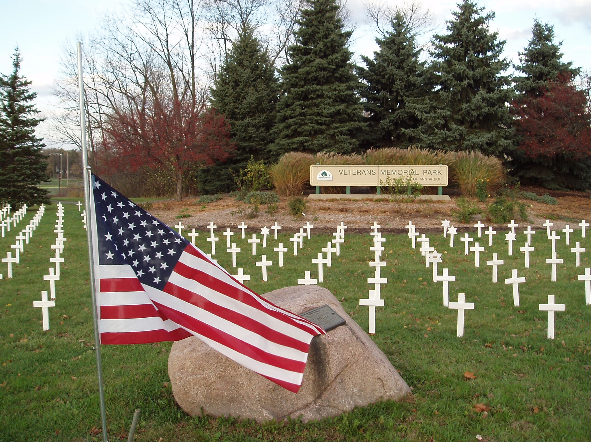Friday, November 11th, 11am until dusk, Veterans Park, Maple and Jackson Roads, Ann Arbor. Veterans/Armistice Day memorial display of one marker for every Michigan soldier lost in the Iraq and Afghan wars (230 markers). The purpose of this display is to honor those who have fallen, to provide a place to grieve, and to educate the public about the costs of war, as well as the needs of those returning from conflicts. Peace ceremony at the white canopy tent at 11am commemorating Armistice Day, 1918 which ended on the eleventh hour of the eleventh day of the eleventh month was regarded at that time as the end of “the war to end all wars.”

The Arlington Michigan display is at the southwest corner of Veterans Park with parking at the Veterans Memorial Ice Arena parking lot (2150 Jackson Avenue, Ann Arbor, MI 48103). Sponsored by Veterans For Peace Chapter 93. Details: www.vfp93.org/arlington-michigan, or call (734) 487-9058. For more on Veterans/Armistice Day visit www.veteransforpeace.org/take-action/armistice-day and for the history of the day at www.va.gov/opa/vetsday/vetdayhistory.asp. For a listing of all Afghan/Iraq war deceased soldiers from Washtenaw County, all Afghan war deceased soldiers from Michigan, and all Iraq war deceased soldiers from Michigan, visit www.vfp93.org/arlington-michigan.
4. VFP Chapter 93’s Concert For Peace Raises Funds For Peace Scholarship Fund
The Chapter’s 15th annual Ark fundraising event, the Concert For Peace (formerly known as the John Lennon Birthday Concert), was held on November 3rd in Ann Arbor and raised $3440 for the Peace Scholarship Fund.

This 15th annual concert was emceed by Chris Buhalis and featured musical artists Dave Keeney & Sophia Hanifi, Annie and Rod Capps, Dave Boutette, Dick Siegel, Judy Banker, Rochelle Clark, Laith Al-Saadi, Rollie Tussing, Michael Smith, Billy King, Jud Branam & Kevin Brown along with Shari Kane & Dave Steele performing peace and justice related songs, including those of John Lennon, to benefit the Chapter's Peace Scholarship Fund.
​
The Peace Scholarship Fund was started in 2007 with a generous donation from John Lennon’s widow, Yoko Ono, and as of November 1, 2022, has awarded $30,000 in scholarships. The Peace Scholarships are made to college students enrolled in peace studies and conflict resolution programs (such as Wayne State University and Michigan State University). For more information on the Veterans For Peace Chapter 93 Peace Scholarships, visit https://www.vfp93.org/peace-scholarship. For current, and past, concert information visit https://www.vfp93.org/concert-for-peace.

5. And Please… Support The Musicians Who Performed At The Concert For Peace!
A big thank you goes out to all the artists that performed at the Concert For Peace with a special thank you to Chris Buhalis for lining up the talent and taking care of all the details to make the concert happen. Also a thank you to Annie Capps for performing with her husband Rod, and creating again a fantastic Concert poster. We urge you to support the musical artists throughout the year by attending their performances and purchasing their recordings (artist web pages can be viewed at https://www.vfp93.org/concert-for-peace). Also, please support The Ark (who provides a great venue for the Concert For Peace concerts) all year, both financially and attending their concerts!

6. VFP Chapter 93 MLK Day Talk Theme - MLK and Militarism: What Would MLK Say Today?
Martin Luther King declared there were three issues that adversely influence American Culture: Racism, Extreme Materialism and Militarism. We are now at the edge of a new international militarism; what would MLK have to say about today's current events? Bob Krzewinski and Bill Shea of local Veterans For Peace chapter 93 will discuss MLK's point of view on Militarism and suggest what he might say about today's situations.
Preliminary planning is taking place with at least three talks in the Ann Arbor – Ypsilanti area in January 2023.

7. Annual Milwaukee VFP Chapter Armistice Day Talk
For a number of years the Milwaukee Chapter of VFP has been holding an Armistice Day program with this year’s talk titled "When will we ever learn?" The talk is led by Reggie Jackson, a public historian, award-winning Milwaukee journalist, co-owner of Nurturing Diversity Partners, member of The Redress Movement national research team, 6-year Navy veteran, head griot at America’s Black Holocaust Museum, and consultant to local, national and international media on race relations, and a sought-after speaker. The talk will be live-streamed via Zoom on November 11th at 8pm EST and you can register here for a Zoom webinar link.

His topic: “When Will We Ever Learn?” He will discuss the seemingly never-ending wars that the US has fought while not winning anything other than the utter destruction of countries the average American cares little about. He will look at the financial and human costs including the treatment of veterans who’ve come back with serious physical and mental trauma. He will ask why we as citizens keep allowing our country to be drawn into wars and who benefits from them and who pays the real cost of war. Will we ever learn from repeated mistakes, or will we continue to make the same critical mistakes time and time again?

8. Announcement, Anniversaries & Reminders
Every Friday – Ann Arbor Anti-War Rally
The Ann Arbor Committee Against War (AACAW) has been gathering for small anti-war rallies every Friday at 5:30 pm, and we always welcome everyone to join them at the Federal Building.

Veterans For Peace National Weekly E-News List
Get updates on upcoming VFP national actions, ongoing campaigns, and news from chapters across the country. Additionally, the e-news provides resources and helpful tips for engaging your own actions. To sign up visit https://veteransforpeace.salsalabs.org/eblast0/index.html.

VFP John Lennon Birthday Benefit Concert CD
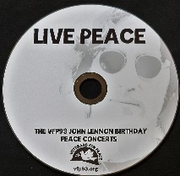Our VFP Chapter has a compact disc (CD) recording of the musical artists performing at our October John Lennon Birthday Benefit Concerts over the years for our Chapter’s Peace Scholarship program. And like the Concert, a purchase of the CD also goes to benefit the Peace Scholarship program. The John Lennon Birthday Benefit Concert CD can be purchased for $15, plus $3 for shipping, by PayPal by visiting www.vfp93.org/john-lennon-concert-cd.

Selections on the John Lennon CD include Revolution (Chris Buhalis, Peter “Madcat” Ruth), Maggie Mae (Dave Boutette, Peter “Madcat” Ruth, Dave Keeney), You’ve Go To Hide Your Love Away (Annie & Rod Capps, Jason Dennie), Lucy In The Sky With Diamonds (Billy King with Emily Slomovits and band), In My Life (Emily Slomvits with Billy King), Dear Prudence (Jo Serrapere), Across The Universe (Jen Sygit), Rest Easy Little Darlin (John Latini), Crippled Inside (Dave Keeney, Sophia Hanfi), Working Class Hero (Rochelle Clark), Come Together (Shari Kane and Dave Steele) and Imagine (Billy King).

Metro Detroit VFP Chapter
The Metro Detroit Chapter of Veterans For Peace covers Wayne, Oakland, Macomb, and Monroe Counties and also has regular meetings. For more information visit https://www.vfp74.org.

Our VFP Chapter Can Use Your Help
Currently our VFP Chapter has only a few people doing all the work and projects and to say we could use help is an understatement. Most of these jobs don’t take up that much time at all, and would help out the Chapter immensely. One thing we are trying to promote is for people to sign up for a “volunteer email list.” We always need extra people to help staff events like the Arlington Michigan display on Memorial/Veterans Day or the VFP booth at Earth Day or the Ann Arbor Art Fair. Just tell us you want to be on the volunteer e-mail list and when an event date starts rolling around, we will email you to see if you can help out. If you can, great. If not, we understand. Even if you are not a veteran, we could still use your help.
To be placed on the “volunteer email list,” just send an email to Bob Krzewinski at wolverbob@gmail.com and he will get back in touch with you. Thanks in advance for your consideration of this request!!!

Thinking About Joining The Military? Already In The Military Seeking Conscientious Objector Status, Delayed Enlistment Problems, Or Release From Service?
Visit our “Thinking About Joining The Military? - Please Read This First” web page at www.vfp93.org/military-recruiting. The page includes before enlisting, how you should be able to honestly answer some basic questions, and have realistic expectations, about military life, a link to the 24-hour ​GI Rights Hotline for people already in the military, and a link to Project YANO (Youth And Non-Military Opportunities) with information about military enlistments, the delayed entry program, and resources for alternatives to the military. Also, you will find a link to the Center On Conscience And War which has information on Selective Service registration, the draft, and conscientious objector status.

