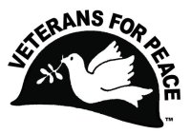Veterans For Peace - Chapter 93

September 2022 Newsletter
… The Utah Phillips – J. David Singer Chapter

Serving Washtenaw, Livingston, Hillsdale, Lenawee, and Jackson Counties.

Local Contact: Bob Krzewinski – 734-487-9058 – wolverbob@gmail.com
www.vfp93.org or on Facebook at www.facebook.com/VFP93

1. Next Veterans For Peace Chapter 93 Meeting – Thursday, September 22nd, 2022, 10:00 am
The next VFP Chapter 93 meeting will be held online only, Thursday, September 22nd, 2022, at 10:00 am. If you would like to participate in the meeting online and your computer has a microphone and video, go to the Zoom meeting link of https://zoom.us/j/95022299743 No computer access? Dial 312-626-6799 and enter the Meeting ID of 950 2229 9743 if prompted,. Anyone can participate in this meeting, or any other VFP Chapter 93 event, be they veteran or not. The meeting agenda is as follows…

- Introductions and welcome
- General Business
  - Previous meeting minutes
  - Treasury report
  - Membership
  - VFP 93 Calendar - 9/21 - International Day of Peace - www.un.org/en/observances/international-day-peace
  - VFP Outreach
  - Other
- Old & continuing business
  - Honorary Chapter member program
  - Truth In Recruiting/Opt-out
  - Washtenaw County Council of Veterans meetings
  - Michigan Peace Alliance
  - Restorative Justice program for Washtenaw County veterans
  - Mayors For Peace Michigan - http://www.mayorsforpeace.org/english/
  - Other
- New Business
  - Jim Rine - Military Budget & Climate Protest In Lansing On September 23rd
  - Other
- Projects
  - Peace Studies Scholarship
  - MLK Day - January
  - Earth Day - April
  - Peace Pole
  - Arlington Michigan – May & November
  - Ann Arbor Art Fair - July
  - Concert For Peace (November 3rd)
  - John Lennon Concert CD
  - Other
- Upcoming events/announcements
- Next meeting
- Adjournment

2. VFP Chapter 93 Meeting Minutes, August 17, 2022 – Online Meeting
Note: Names with all letters capitalized indicate action needed by that Chapter member

- Introductions and welcome - The meeting began at 7:34pm via Zoom teleconference. Present were
Mike Muha, Bill Shea, Eric Van DeVort, Jim Rine and Bob Krzewinski.

- General Business
  - Previous meeting minutes - Accepted
  - Treasury report - $5240.74 in the treasury.
  - Membership – 24 members on the August membership list with 6 lapsed. BOB will email those whose membership lapsed.
  - VFP 93 Calendar - Chapter communication went out about Hiroshima (August 6) bombing anniversary with online events being held, including one by VFP 74 Vice Chair Jim Rine. August 10th was International Agent Orange Day with the August Chapter newsletter encouraging readers to ask their U.S. Representative to support Agent Orange aid to victims. August and September are prime time for having high school students to opt-out of contact by military recruiters. 9/21/2022 is the United Nations International Day of Peace - www.un.org/en/observances/international-day-peace
  - VFP Outreach – The VFP Art Fair table in Ann Arbor went well.

- Old & continuing business
  - Honorary Chapter member program – No new updates.
  - Truth In Recruiting/Opt-out – BILL will contact Steve Morehouse about truth in recruiting material.
  - Washtenaw County Council of Veterans meetings -BILL will try to attend the September meeting on the 3rd Monday in Milan.
  - Michigan Peace Alliance – BILL has been attending online meetings. BILL will also meet with MIKE to go over Facebook postings from VFP to the Alliance Facebook page.
  - Restorative Justice program for Washtenaw County veterans – No new updates.
  - Mayors For Peace Michigan - http://www.mayorsforpeace.org/english/ - Bob made contact.
  - Rotary Peace Conference – Postponed from September 23/24 due to COVID concerns.

- New Business
  - Jim Rine (VFP 74 Acting Vice Chair) Veterans For Peace Climate Crisis and Militarism Project – Gave an update on the Project and the Washington DC direct action protest resulting in activists ben arrested. Also, local climate actions were discussed.
  - VFP Golden Rule Project Coming To The Great Lakes – Discussed the Golden Rule travelling into Detroit – 8/15 – 8/22) In 2023 and possible actions

- Projects
  - Peace Studies Scholarship
  - MLK Day – January – No new news.
  - Earth Day – April – No new news.
  - Peace Pole – No new news.
  - Arlington Michigan – May & November - Veterans Park in Ann Arbor has been rented for our Chapter’s Arlington Michigan display of one grave marker for every Michigan soldier killed in the Iraq and Afghan war (230) with the event running from 11am to 5pm.
  - Ann Arbor Art Fair – July – Display area confirmed for July 21-23. July Chapter meeting will be held at the Art Fair on Saturday, July 22nd at 1pm.
  - Concert For Peace (November 3rd) – BILL will continue talking with Chris Buhalis on Concert planning.
  - John Lennon Concert CD – Still, many available. On thought was a CD could be given to anyone buying a concert ticket this November.

- Upcoming events/announcements - August 25th-28th - VFP Annual Convention – Ads placed for both Chapters 74 and 93 as a fundraise for the national organization.

- Next meeting – 9/21/2022, 7pm, Zoom

- Adjournment – Adjourned at 8:24pm

3. Concert For Peace (…formerly known as the John Lennon Birthday Concert)
A Benefit for the Veterans For Peace Chapter 93 Peace Scholarship Fund
Thursday, November 3rd, 2022 - 7:30pm (doors open at 7pm)
The Ark, 316 South Main Street, Ann Arbor, MI

This 15th annual concert will be emceed by Chris Buhalis. The line-up for this year’s concert is yet to be announced but the 2021 concert included Laith Al-Saadi, Mr. B, Judy Banker, Al Bettis, Dave Boutette & Kristi Davis, Jud Branam and Kevin Brown, Annie & Rod Capps, Rochelle Clark, Jason Dennie, Jill Jack, Dave Keeney & Sophia Hanifi, Dick Seigel, and Matt Watroba. Musical artists will be performing peace and justice related songs, including a tribute to John Lennon, who’s widow Yoko Ono, made a generous donation in 2007, to establish the Peace Scholarship Fund. .

For COVID requirements, please review any vaccination and masking requirements at https://theark.org/covid-19-updates/ prior to attending the concert. $20 admission. Proceeds go to scholarships for college students enrolled in peace studies and conflict resolution programs. For advance tickets visit https://theark.org/event/concert-for-peace-221103/ or call (734) 763-8587. For more information on the Veterans For Peace Chapter 93 Peace Scholarships, visit https://www.vfp93.org/peace-scholarship.

- Volunteers Needed For Military Budget & Climate Protest In Lansing On September 23rd
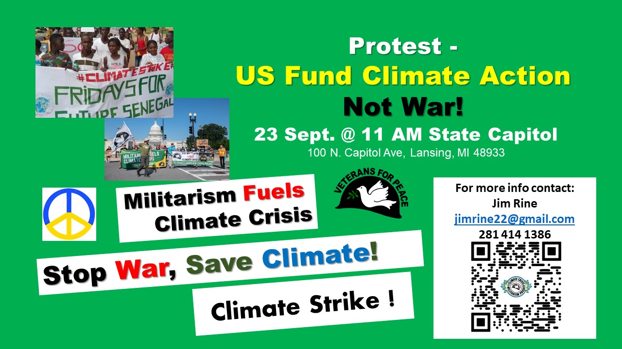 Volunteers are needed to help in a Lansing protest on 23 September protesting against the obscenely large military spending versus real needs like fighting climate change, supporting healthcare, funding education, etc. The support roles needed should not lead to arrest. Timing of the protest coincides with budget debates in Congress that include the National Defense Authorization Act (NDAA) and the international Fridays for Future climate strikes inspired by Greta Thunberg - https://fridaysforfuture.org/september23/ . The protest in Lansing will hopefully be similar to the one carried out in DC in early August - (https://www.veteransforpeace.org/pressroom/news/2022/08/03/release-military-veterans-arrested-demanding-presidential-co ) where only designated VFP members were arrested.

Everyone is invited to participate in support, but the following support roles need to be filled:
- Spokesperson - during event, pass out statements to any press present and answer questions. After event work with photographer and media person (TBD) to select photos and add captions for press releases that
- On-site “legal” support – Collect and keep personal items of arrestees (wallet, keys, phone, etc.). Keep track of where arrestees are and arrange for someone meeting them after release.
- Legal liaison – If you have experience with this, please let us know. Will entail talking to police who should have already been briefed. May have Lansing-area person handling this.

For more information, contact Jim Rine of VFP74 and the Climate Crisis & Militarism Project (https://www.veteransforpeace.org/take-action/climatecrisis) at jimrine22@gmail.com or 281-414-1386.

- State Of Veterans For Peace
These reports are from the VFP National Convention in late August…
Executive Director's Report - https://www.veteransforpeace.org/files/3516/6153/8807/Executive_Director_Report_Convention_2022_1.pdf
President's Report - https://www.veteransforpeace.org/files/9916/6118/9314/VFP_Presidents_Report_2022_Business_Meeting.pdf
Treasurer's Report - https://www.veteransforpeace.org/files/9216/6154/5775/Treasurers_Report_August_2022_w.pdf
Membership Report - https://www.veteransforpeace.org/files/3416/6137/1447/Membership_Report_2022.pdf

- Help Support RENEW To Help Heal The Wounds Of War In Vietnam
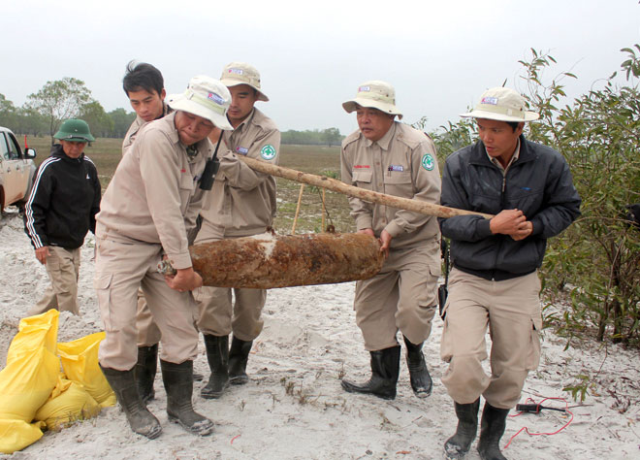Since the war's end in 1975, bombs left behind have killed or injured over 105,000 people in Vietnam, one-third of them children. Since 2001, RENEW - https://renewvn.org - and its NGO partners, have cleared 762,418 live explosives but there's much more to do.

The following is a short note from VFP member, and Vietnam veteran, Doug Rawlings… “Hope you are well. I'm sending this request to you and your VFP chapter as the RENEW project in Viet Nam, led by VFP member Chuck Searcy, is attempting to expand beyond the Quang Tri Province.

One of the areas they are planning to cover is Quang Ngai Province where the village of My Lai is located. Personally, I know the damage that artillery shells, bombs and landmines can do -- I was with the 7/15th Artillery in the Central Highlands from 1969 to 1970-- and I know, deep down, that the people of Viet Nam continue to suffer because of that war.

There is a fundraiser being planned for September 21st in Washington, DC, and I was hoping that you might be able to contribute to it. Our Maine chapter of VFP is donating $500.00 to the cause because we know that Chuck Searcy will put it to good use. Please join me and our chapter in helping to alleviate some of that suffering and protect the grandchildren of those who survived My Lai from being maimed or killed by the bombs and landmines we left behind. If you're interested in helping out, you can do so by credit card, or PayPal, by going to https://renewvn.org/donate/ -- the website for Friends of Project Renew.

In addition to your chapter, you may know some individuals who have the means and the desire to contribute. Please spread the word. Take good care. And thanks. Yours in peace, Doug Rawlings”

- September 21st – United Nations International Day Of Peace
Each year the International Day of Peace is observed around the world on September 21. The United National General Assembly has declared this as a day devoted to strengthening the ideals of peace, through observing 24 hours of non-violence and cease-fire. The 2022 theme for the International Day of Peace is “End racism. Build peace.” To give meaning to this day, we hope you can do the following…

- Visit the UN International Day of Peace web page at https://www.un.org/en/observances/international-day-peace
- Take in the United for Peace & Justice group’s special webinar: “End Racism. Build Peace,” September 21st, 8pm to 9:30pm EDT. Register at https://www.codepink.org/ufpj_09212022
- Visit the Ann Arbor Ann Arbor United Nations International Day of Peace Celebration, September 21st, Community Commons, Library Lane and Fifth Avenue. 8am to 10pm. Full schedule at https://tinyurl.com/AAPeaceDay2022. Volunteers invited to join the Peace Day Working Committee. Contact Alan Haber. megiddo@umich.edu 734-657-8083.
- Sign up for the webinar “Active, Courageous Nonviolence Is The Only Way To End Racism & Build Peace’ – The presenter is Peter Dougherty, a founder of the Meta Peace Team (MPT) and a Catholic priest of the diocese of Lansing, MI. This webinar will be held Sunday, September 18th, from 3pm to 4:30pm EDT. Register at https://tinyurl.com/META-Peter

- September is Suicide Prevention Month: Learn How To Be There For Veterans In Crisis
If you or someone you know is in crisis, contact the Veterans Crisis Line:
- 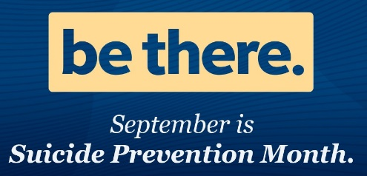Website: https://www.veteranscrisisline.net
- Call 988 and press 1 (new number)
- Text Message: 838255
- Chat online at www.veteranscrisisline.net/get-help/chat
- VA support for deaf and hard of hearing – click here

Reach out and stay connected to the Veteran in your life. Be There. For a Veteran facing hard times, your support can provide hope when it’s needed most—and you already have what it takes to show you care. Take a few minutes to check in today. Here are some ideas to help you get started with a call, text, or email…
- Talking on the phone with your Veteran loved ones can strengthen your connection. Calling to just catch up is important—especially during this unpredictable time.
- Not only does an open and honest conversation help people feel less alone, but it also can give you a window into their experiences.

If you’re worried about someone, you might need to have a more serious conversation.
- Remind them you are there for them, even if physically apart. It’s easier to feel isolated these days—so reaching out is more important than ever.
- Validate their experience. Listen more than you speak—don’t dominate the conversation. Even if you can’t relate to what they are going through, you can tell them you understand that they went through something difficult and show them you respect their feelings about it.
- Let them decide how much information to share. Supportive and encouraging comments, rather than invasive personal questions, will create a space for open communication and avoid putting them on the defensive.
- If you’re concerned, it’s okay to ask directly if they are thinking about suicide. Asking questions about thoughts of suicide does not increase a person’s suicide risk, and the answers can help you determine the next steps to take.

Resources – (click links below to open in new tab)
- Suicide – Make the Connection - www.maketheconnection.net/conditions/suicide
- VA’s Suicide Prevention Site - www.mentalhealth.va.gov/suicide_prevention/index.asp
- Veterans Self-Check Quiz - www.vetselfcheck.org/disclaimer.cfm

- Short Reads..
- How Peace Activists (Including VFP) Are Beating the U.S. Military at its Own (Video) Game - https://progressive.org/topics/gallagher/
- ‘The Time to Stop the Holocaust is Before it Happens’: An Interview with Ken Burns - https://progressive.org/latest/stop-holocaust-before-it-happens-ken-burns-rampell-091222/ The U.S. and the Holocaust premieres on PBS September 18, 19 and 20, at 8pm ET.
10. Announcement, Anniversaries & Reminders
Saturday, October 22nd - Charlie King & Annie Patterson Benefit Concert For The ICPJ
7pm, Church of the Good Shepherd, 2145 Independence Boulevard, Ann Arbor, MI 48104 - Charlie King is a musical storyteller and political satirist who sings and writes passionately about the extraordinary lives of ordinary people, in the tradition of Woody Guthrie, Malvina Reynolds, and Pete Seeger (see www.charlieking.org). Charlie has performed in Ann Arbor since 1979 and won the Phil Ochs Award for music and activism in 2017. Concert proceeds benefit the Interfaith Council for Peace & Justice (www.icpj.org). Masks are required for in-person attendees, and online streaming is also available. For tickets and more information visit https://www.icpj.org/blog/2022/2022-charlie-king-annie-patterson-icpj-benefit-concert/

Every Friday – Ann Arbor Anti-War Rally
The AACAW has been gathering for small anti-war rallies every Friday at 5:30 pm, and we always welcome you to join us there at the Federal Building. And we are interested in having a cooperative relationship with VFP.

Veterans For Peace National Weekly E-News List
Get updates on upcoming VFP national actions, ongoing campaigns, and news from chapters across the country. Additionally, the e-news provides resources and helpful tips for engaging your own actions. To sign up visit https://veteransforpeace.salsalabs.org/eblast0/index.html.

Support Those Who Supported Us For Our John Lennon Concert!
We again thank our musical artists who are contributing their talent to make our 2019 John Lennon benefit concert a success and urge you to support them throughout the year by attending their performances and purchasing their recordings. Visit https://www.vfp93.org/john-lennon-concert for a listing of concert musicians.

VFP John Lennon Birthday Benefit Concert CD
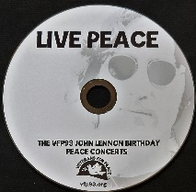Our VFP Chapter has a compact disc (CD) recording of the musical artists performing at our October John Lennon Birthday Benefit Concerts over the years for our Chapter’s Peace Scholarship program. And like the Concert, a purchase of the CD also goes to benefit the Peace Scholarship program. The John Lennon Birthday Benefit Concert CD can be purchased for $15, plus $3 for shipping, by PayPal by visiting www.vfp93.org/john-lennon-concert-cd.

Selections on the John Lennon CD include Revolution (Chris Buhalis, Peter “Madcat” Ruth), Maggie Mae (Dave Boutette, Peter “Madcat” Ruth, Dave Keeney), You’ve Go To Hide Your Love Away (Annie & Rod Capps, Jason Dennie), Lucy In The Sky With Diamonds (Billy King with Emily Slomovits and band), In My Life (Emily Slomvits with Billy King), Dear Prudence (Jo Serrapere), Across The Universe (Jen Sygit), Rest Easy Little Darlin (John Latini), Crippled Inside (Dave Keeney, Sophia Hanfi), Working Class Hero (Rochelle Clark), Come Together (Shari Kane and Dave Steele) and Imagine (Billy King).

Our VFP Chapter Can Use Your Help
Currently our VFP Chapter has only a few people doing all the work and projects and to say we could use help is an understatement. Most of these jobs don’t take up that much time at all, and would help out the Chapter immensely. One thing we are trying to promote is for people to sign up for a “volunteer email list.” We always need extra people to help staff events like the Arlington Michigan display on Memorial/Veterans Day or the VFP booth at Earth Day or the Ann Arbor Art Fair. Just tell us you want to be on the volunteer e-mail list and when an event date starts rolling around, we will email you to see if you can help out. If you can, great. If not, we understand. Even if you are not a veteran, we could still use your help.
To be placed on the “volunteer email list,” just send an email to Bob Krzewinski at wolverbob@gmail.com and he will get back in touch with you. Thanks in advance for your consideration of this request!!!

Metro Detroit VFP Chapter
The Metro Detroit Chapter of Veterans For Peace covers Wayne, Oakland, Macomb, and Monroe Counties and also has regular meetings. For more information visit https://www.vfp74.org.

Thinking About Joining The Military? Already In The Military Seeking Conscientious Objector Status, Delayed Enlistment Problems, Or Release From Service?
Visit our “Thinking About Joining The Military? - Please Read This First” web page at www.vfp93.org/military-recruiting. The page includes before enlisting, how you should be able to honestly answer some basic questions, and have realistic expectations, about military life, a link to the 24-hour ​GI Rights Hotline for people already in the military, and a link to Project YANO (Youth And Non-Military Opportunities) with information about military enlistments, the delayed entry program, and resources for alternatives to the military. Also, you will find a link to the Center On Conscience And War which has information on Selective Service registration, the draft, and conscientious objector status.

