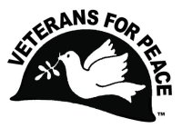Veterans For Peace - Chapter 93

March 2023 Newsletter
… The Utah Phillips – J. David Singer Chapter

Serving Washtenaw, Livingston, Hillsdale, Lenawee, and Jackson Counties.

Local Contact: Bill Shea – 734-662-0818 (cell/text) – billshea@umich.edu
www.vfp93.org or on Facebook at www.facebook.com/VFP93

1. Next Veterans For Peace Chapter 93 Meeting - Tuesday, March 21st, 7:30pm
The next VFP Chapter 93 meeting will be held online only, Tuesday, March 21st at 7:30pm. If you would like to participate in the meeting online and your computer has a microphone and video, go to the Zoom meeting link of https://zoom.us/j/95022299743 No computer access? Dial 312-626-6799 and enter the Meeting ID of 950 2229 9743 if prompted,. Anyone can participate in this meeting, or any other VFP Chapter 93 event, be they veteran or not. The meeting agenda is as follows…

- Introductions and welcome
- General Business
  - Previous meeting minutes
  - Treasury report
  - Membership
  - VFP 93 Calendar • My Lai – March 16, 1968, • Iraq war start – March 20, 2003
  - Other
- Old & continuing business
  - Honorary Chapter member program
  - Full Disclosure Recruiting
  - Michigan Peace Alliance
  - Washtenaw County Council of Veterans
  - Camp Grayling expansion – Draft VFP Chapter 93 opposition statement to expansion.
  - Other
- New Business
  - VFP Golden Rule sailboat stop at Detroit
  - Other
- Projects
  - Peace Studies Scholarship
  - MLK Day - January
  - Earth Day – April – Ypsilanti event Sunday, Apr 16, 12pm– 5 pm, Ypsilanti Freighthouse, Ann Arbor event Sunday, April 24, Leslie Science Center
  - Peace Pole
  - Arlington Michigan – May & November
  - Concert For Peace – October 12, 2023 (tentative)
  - Other
- Upcoming events/announcements – VFP Regional “mini-conventions”
- Next meeting
- Adjournment

2. VFP Chapter 93 Meeting Minutes, February 21st, 2023
- Introductions and welcome - Meeting began at 7:32pm online over Zoom. Present were Mike Muha, Bill Shea, Bob Krzewinski, Ken Parks and Mark Jagner of the at First Unitarian Universalist Congregation of Ann Arbor.
- General Business
      - Previous meeting minutes – Accepted
      - Treasury report - Mike reported $7469.53 in the Bank of Ann Arbor and $50 in a PayPal account.
      - Membership – Twenty four members with nine lapsed. National VFP dues will rise to $50/year effective March 1st, 2023.
      - VFP 93 Calendar • My Lai – March 16, 1968, • Iraq war start – March 20, 2003 – BOB will post these events in the Chapter & Facebook web pages and in the March Chapter newsletter.
- Old & continuing business
      - Honorary Chapter member program - Phil Larson, Program Director of the University of Michigan Veteran and Military Services Program (VMSP) office, was awarded the 2023 honorary Chapter member at the January at the VFP Chapter 93 Martin Luther King Day program at the University. Mike will take care of the VFP national membership and BOB will update the VFP 93 website (https://www.vfp93.org/vfp-93-honorary-members).
      - Full Disclosure Recruiting – It was decided that Chapter actions to give high school students more education on military service will be known as “Full Disclosure Recruiting”. Related to that subject, BILL and STEVE Morehouse have been working on Full Disclosure Recruiting handouts and Bill is communicating with Ann Arbor Pioneer High School staff on having a VFP Full Disclosure table at their career fair on April 17th.
      - Michigan Peace Alliance – Bill gave a report on the groups action.
      - Washtenaw County Council of Veterans – BILL will attend meetings when possible. Also, a $25.00 yearly renewal in the Council of Veterans was approved with BILL and MIKE working to submit.
      - Camp Grayling expansion – Draft VFP Chapter 93 opposition statement to base expansion. BOB is currently asking for input from the three Michigan VFP Chapters on a resolution that would be forwarded to legislators, the Governor, appropriate non-profit groups and the media. BOB will be going over the document to edit it further and add bookmarks and will send an updated version to Chapter 93 before it is sent to the Detroit and Traverse City VFP Chapters for any final comments.
- New Business
      - VFP Golden Rule sailboat stop at Detroit – After leaving Toledo, the Golden Rule will arrive in Detroit for a visit over September 12th to the 17th. The Metro Detroit Chapter will coordinate local activities for the visit. Suggestions heard tonight included working with the Citizens’ Resistance at Fermi Two (CRAFT - https://www.shutdownfermi.org) as the sailboat will pass by the two Fermi reactors and involving Indigenous (Native Americans) groups. BRUCE Baran from Metro Detroit VFP will be coordinating the visit and can be reached at bpbaran@gmail.com.
      - Endorsement of "A General's Son: Journey of an Israeli in Palestine” program at First Unitarian Universalist Congregation of Ann Arbor on 3/19/2023 - Mark Jagner from the UU Congregation discussed the upcoming program including a short recorded preview. The request for the VFP Chapter to endorse the talk was approved and MARK will forward a press release to BOB who will post the release on the Chapter and Facebook web page and also in the March Chapter newsletter.
      - Other – Bob and Jim Rine of the Metro Detroit Chapter staffed a VFP information table at the Saturday State Democratic convention in downtown Detroit.
- Projects
      - Peace Studies Scholarship – BILL reported that a previous awardee would like to apply for another Scholarship grant and BILL will pass the information on to the Chapter once received.
      - MLK Day – January – BILL reported a new book has been published that chronicles MLK in the calendar year 1966.
      - Earth Day – BOB will investigate having a VFP table at the Ypsilanti Earth Day event Sunday, April 16, 12pm– 5 pm, Ypsilanti Freighthouse. BOB will submit an application for the Ann Arbor Earth Day event on April 24th.
      - Peace Pole – Those attending were asked to come up with possible locations for new Peace Pole installations and also a raffle fundraiser to win a Peace Pole.
      - Arlington Michigan – May & November – BOB reported that a permit application was submitted for a May Memorial Day display in Detroit’s Grand Circus Park – East. Bill reported that the rental of Veterans Park on Armistice (Veterans) Day had been approved.
      - Concert For Peace – October 12, 2023 – BILL is in communication with The Ark and also Chris Buhalis on a 2023 Concert.

6) Upcoming events/announcements
VFP Regional “mini-conventions” (i.e. Friday, Saturday, Sunday). are being planned for the future with the first being in Minneapolis/St. Paul this year. More details will be posted in national VFP communications.
7) Next meeting – Tuesday, March 21, 2023, 7:30pm online Zoom meeting.
8) Adjournment – Meeting adjourned at 8:32pm

3. VFP Chapter 93 Full Disclosure Recruiting Table At Ann Arbor High School College Fair
For the third time, our VFP Chapter 93 will be having an information table at an Ann Arbor Pioneer High School College Fair on Monday, April 17, 2023 from 6pm-7:30pm. Full Disclosure Recruiting involves discussions with students about military recruiting, factual information military life, the military enlistment contract and alternatives to the military. Military recruiters will also have displays at the Fair. Pioneer High School located at 601 W. Stadium Boulevard in Ann Arbor. For more information visit https://sites.google.com/aaps.k12.mi.us/cube/college-and-career-fair-23

4. VFP Golden Rule Sailboat Visit To Detroit Update
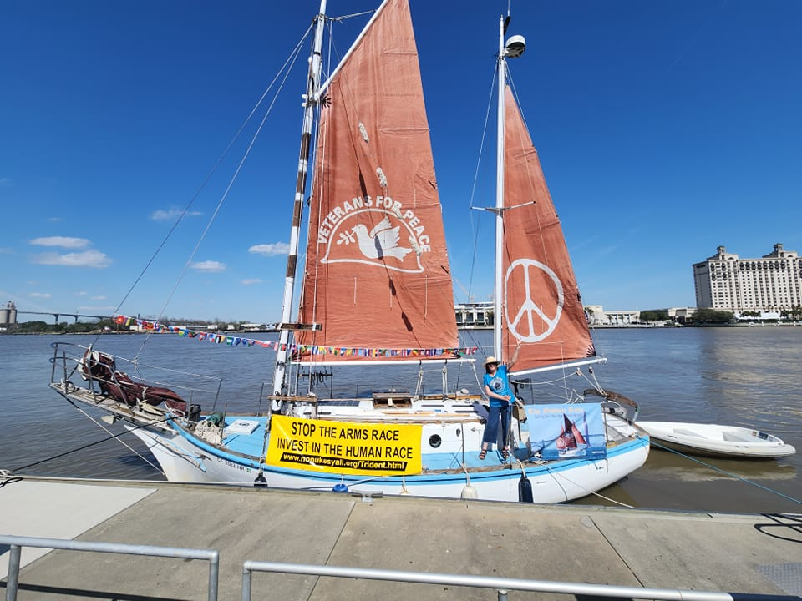 The VFP sailboat “Golden Rule”, which in 1958 set sail to stop nuclear weapons tests in the Marshall Islands is currently travelling up the intercoastal waterway and expected to dock in the Norfolk Virginia area in mid-March, the metro Washington DC region from April 2nd and New York City on May 20th. For a complete listing of all the cities the Golden Rule will visit, go to https://bit.ly/GRGLSched. Currently, the Golden Rule is scheduled to head west on the Great Lakes, stopping at Toledo on August 10 to the 13th and in Detroit on August 13th through the 17th. Please note, however, that all dates are still tentative.

The Metro Detroit VFP Chapter 74 is teaming with Chapter 93 (south central Michigan) to sponsor activities surrounding the visit to Detroit. Anyone interested in planning this Detroit event should attend monthly Chapter meetings or contact Bruce Baran of Chapter 74 at bpbaran@gmail.com. For more information on the Golden Rule, along with an interactive map, visit https://vfpgoldenruleproject.org. Their Facebook page at https://www.facebook.com/GoldenRulePeaceBoat.

5. Saturday. March 18 -- National March on Washington: Fund People's Needs, Not the War Machine!
A number of organizations, including Veterans For Peace, will be participating in a gathering on Saturday, March 18th (the 20th anniversary of the U.S. invasion of Iraq) to push for funding programs for people, not the military and to end the war in the Ukraine. For more information, visit https://www.codepink.org/piu20iraq or https://www.answercoalition.org/protest_march_18_19_peace_in_ukraine_say_no_to_endless_u_s_wars. The veterans contingent (made up of Veterans For Peace, About Face - Veterans Against the War, and Eyes Left) has their own page at https://www.answercoalition.org/join_the_veterans_and_gis_contingent_on_march_18

Also, please note that Jim Rine, the Metro Detroit VFP Chapter Vice-Chair is organizing a carpool and if interested, contact Jim at jimrine22@gmail.com.

6) Support Staffing The VA
The national Veterans For Peace Save Our VA Steering Committee is alerting veterans that the VA cannot provide health care to veterans if it does not have staff. The VA, like the rest of health care in the US, is being impacted by the national shortage of health care workers at all levels that has been worsened by the COVID pandemic. This is compounded by the VA being unable to match salaries being offered in the private sector. The recently introduced bill, S.10 - VA Clinician Appreciation, Recruitment, Education, Expansion, and Retention Support (CAREERS) Act of 2023, offers some steps to make the VA more competitive, including authorizing modifications of pay limitations for specialty medical positions and increasing salary caps for certain leadership positions.

It is difficult to know the number of current staffing vacancies in the VA but it reported nearly 77,000 at the end of 2022. An OIG report (OIG Determination of Veterans Health Administration’s Occupational Staffing Shortages Fiscal Year, # 2022 22-00722-187) found that all 139 VHA facilities reported at least one severe occupational staffing shortage. Insufficient staffing increases referrals to the private sector under the Veterans Community Care Program (VCCP). VCCP care costs more than VA care. Less money for VA care affects VA staffing. Insufficient staff results in more VCCP referrals. Veterans lose their ability to choose the VA as a provider of high-quality healthcare.

Click this link - https://www.veteransforpeace.org/take-action/stop-privatization-veterans-health-administration/take-action-saveourva/careersactcta - to urge your Senators to support S.10 - VA Clinician Appreciation, Recruitment, Education, Expansion, and Retention Support (CAREERS) Act of 2023. Please modify the letters by clicking on the letter and adding a few words, such as “I’m a veteran (family member/friend of a veteran)” as personalized letters receive more attention.
The Veterans Healthcare Policy Institute (VHPI) in conjunction with the American Federation of Government Employees (AFGE) will issue a complete report on a staffing survey next month. Read a summary of findings at VA System Under Strain Due to Staffing Shortages + Care Outsourcing.

VHPI wrote a staffing report in 2020 explaining many of the issues that affect staffing. Find it at The VA's Vacancy Crisis.

Human Resource management intensifies VA staffing shortages. Read about this at Trump’s VA Legacy: Human Capital Mismanagement. Even though Trump is named in the title, these issues continue in the Biden administration

7. Announcement: Increase in VFP Dues
From the VFP national office… It has been at least a decade since VFP dues were raised from $25 to $40, even as costs have continued to grow. The VFP Board of Directors recently elected to increase basic membership fees from $40 to $50 annually. This slight increase in annual dues is in line with the challenges of our times. This increase will go into effect at the end of February. We’ll continue to monitor expenditures and pledge to increase revenue through other means during the course of the year.

As a valued member of the community, your continued support enhances VFP's continued commitment to peace and ending wars. Lifetime membership will remain at the amount of $1,000. As always, active duty membership is without cost, reduced and student due rates remain the same, and scholarships are available.

8. Quote Of The Month…
“When I despair, I remember that all through history the way of truth and love have always won. There have been tyrants and murderers, and for a time, they can seem invincible, but in the end, they always fall. Think of it--always.” ― Mahatma Gandhi

9. Announcement, Anniversaries & Reminders
March 19 (Sunday) – “The General’s Son, Journey of an Israeli in Palestine”
In this recorded talk, Miko Peled gives a clear and candid view of the Israel-Palestinian issue and what can be done to bring about lasting peace. He shares his personal journey of transformation from serving in the military as a member of a prominent Zionist family to becoming an activist for Palestinian human rights. 1:00 pm - 3:00 pm, 4001 Ann Arbor-Saline Road, Ann Arbor, Michigan 48103-8739 (map at https://goo.gl/maps/7EuMiUbi98X21bX8A).

Every Friday – Ann Arbor Anti-War Rally
The Ann Arbor Committee Against War (AACAW) has been gathering for small anti-war rallies every Friday at 5:30 pm, and we always welcome everyone to join them at the Federal Building. For more information about the AACAW visit https://www.annarborcoalitionagainstwar.org

Veterans For Peace National Weekly E-News List
Veterans For Peace puts out a weekly eNews that features a weekly summary of news from Veterans For Peace members, chapters and the National office. To sign up for the Weekly eNews, click here!

VFP John Lennon Birthday Benefit Concert CD
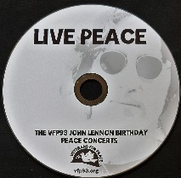Our VFP Chapter has a compact disc (CD) recording of the musical artists performing at our October John Lennon Birthday Benefit Concerts over the years for our Chapter’s Peace Scholarship program. And like the Concert, a purchase of the CD also goes to benefit the Peace Scholarship program. The John Lennon Birthday Benefit Concert CD can be purchased for $15, plus $3 for shipping, by PayPal by visiting www.vfp93.org/john-lennon-concert-cd.

Selections on the John Lennon CD include Revolution (Chris Buhalis, Peter “Madcat” Ruth), Maggie Mae (Dave Boutette, Peter “Madcat” Ruth, Dave Keeney), You’ve Go To Hide Your Love Away (Annie & Rod Capps, Jason Dennie), Lucy In The Sky With Diamonds (Billy King with Emily Slomovits and band), In My Life (Emily Slomvits with Billy King), Dear Prudence (Jo Serrapere), Across The Universe (Jen Sygit), Rest Easy Little Darlin (John Latini), Crippled Inside (Dave Keeney, Sophia Hanfi), Working Class Hero (Rochelle Clark), Come Together (Shari Kane and Dave Steele) and Imagine (Billy King).

Metro Detroit VFP Chapter
The Metro Detroit Chapter of Veterans For Peace covers Wayne, Oakland, Macomb, and Monroe Counties and also has regular meetings. For more information visit https://www.vfp74.org.

Our VFP Chapter Can Use Your Help
Currently our VFP Chapter has only a few people doing all the work and projects and to say we could use help is an understatement. Most of these jobs don’t take up that much time at all, and would help out the Chapter immensely. One thing we are trying to promote is for people to sign up for a “volunteer email list.” We always need extra people to help staff events like the Arlington Michigan display on Memorial/Veterans Day or the VFP booth at Earth Day or the Ann Arbor Art Fair. Just tell us you want to be on the volunteer e-mail list and when an event date starts rolling around, we will email you to see if you can help out. If you can, great. If not, we understand. Even if you are not a veteran, we could still use your help.

To be placed on the “volunteer email list,” just send an email to Bob Krzewinski at wolverbob@gmail.com and he will get back in touch with you. Thanks in advance for your consideration of this request!!!

Thinking About Joining The Military? Already In The Military Seeking Conscientious Objector Status, Delayed Enlistment Problems, Or Release From Service?
Visit our “Thinking About Joining The Military? - Please Read This First” web page at www.vfp93.org/military-recruiting. The page includes before enlisting, how you should be able to honestly answer some basic questions, and have realistic expectations, about military life, a link to the 24-hour ​GI Rights Hotline for people already in the military, and a link to Project YANO (Youth And Non-Military Opportunities) with information about military enlistments, the delayed entry program, and resources for alternatives to the military. Also, you will find a link to the Center On Conscience And War which has information on Selective Service registration, the draft, and conscientious objector status.

